**SCOPE OF MACHINE LEARNING FOR MECHANICAL ENGINEERING**

**MAJOR PROJECT REPORT**

***Submitted in partial fulfillment of th*e *requirements for the Award of the Degree***

***Of***

**BACHELOR OF TECHNOLOGY**

***In***

**MECHANICAL AND AUTOMATION ENGINEERING**

***By***

**Mohd. Faizan Gaurav Akshit Gupta Dhruv Parasher**

00696203617 41196203617 41296203617 41596203617

***Guided by***

***Dr. Deepak Bhardwaj***

 **(Dept. of Mechanical and Automation Engineering)**

**DR. AKHILESH DAS GUPTA INSTITUTE OF TECHNOLOGY AND MANAGEMENT**

(AFFILIATED TO GURU GOBIND SINGH INDRAPRASTHA UNIVERSITY)

**NEW DELHI – 110078.**

**[March - July 2021]**

# ABSTRACT

Machine learning is concerned with enabling computer programs automatically to improve their performance at some tasks through experience. Manufacturing is an area where the application of machine learning can be very fruitful. However, little has been published about the use of machine- learning techniques in the manufacturing domain. This paper evaluates several machine-learning techniques and examines applications in which they have been successfully deployed. Special attention is given to inductive learning, which is among the most mature of the machine-learning approaches currently available. Current trends and recent developments in machine-learning research are also discussed. The paper concludes with a summary of some of the key research issues in machine learning.



### Department of Mechanical & Automation Engineering

**Dr. Akhilesh Das Gupta Institute of Technology & Management Delhi-53**

**Certificate**

It is certified that the work contained in this report titled ***“SCOPE OF MACHINE LEARNING FOR MECHANICAL ENGINEERING”*** is the original work done by Mohd. Faizan *(00696203617)*, Gaurav *(41196203617)*, Akshit Gupta *(41296203617),* Dhruv Parasher *(41596203617)* and has been carried out under our supervision.

***Dr. Deepak Bhardwaj Mr. Neeraj Kumar***

### (Project Supervisor) (Head of department)

**Signature of External Examiner: …………………**

**ACKNOWLEDGEMENT**

We express our deep gratitude to **Dr. Deepak Bhardwaj**, Associate Professor, Department of Mechanical and Automation Engineering for his valuable guidance and suggestion throughout our project work.

We would like to extend our sincere thanks to **Dr. Deepak Bhardwaj** for his time-to-time suggestion to complete our project work. We are also thankful to **Prof. (Dr.) Sanjay Kumar (Director)** for providing us the facilities to carry out our project work.

Sign:Sign:

**Mohd. Faizan Gaurav**

“00696203617” “41196203617”

Sign: Sign:

**Akshit Gupta Dhruv Parasher**

“41296203617” “41596203617”

**Table of Content**

|  |  |
| --- | --- |
| **Heading** | **Page No.** |
| * Abstract | 2 |
| * Certificate | 3 |
| * Acknowledgment | 4 |
| * Table of Content | 5 - 6 |
| * Introduction | 7 - 8 |
| * Objective | 9 |
| * Theory | 10 - 12 |
| * Data Processing | 10 |
| * Categories of Machine Learning | 10 |
| * Supervised Learning | 11 |
| * Unsupervised Learning | 11 |
| * Semi-Supervised Learning | 12 |
| * Reinforcement Learning | 12 |
| * Machine Learning Components | 13 |
| * Methodology | 14 - 17 |
| * Program | 18 – 30 |
| * Simple Linear Regression | 18 - 20 |
| * Multiple Linear Regression | 21 – 23 |
| * Polynomial Linear Regression | 25 – 28 |
| * Logistic Regression | 28 - 30 |
| * Advantages of Machine Learning | 31 - 35 |
| * Application of Machine Learning | 36 - 41 |
| * Techniques of Machine Tool Monitoring | 42 |
| * How AE Sensors Monitors Machine tools | 42 - 43 |
| * Types of Sensors | 44 |
| * Conclusion | 45 |
| * Future Scope | 46 – 47 |
| * References | 48 |

# 

# INTRODUCTION

Mechanical engineers are both consumers of machine learning and critical facilitators of it. As we design and apply machines and employ applied physics in bio-medical devices, transportation technology, manufacturing and myriad other areas, machine learning is critical in the implementation of practical technology and an important element in providing better, smarter results.

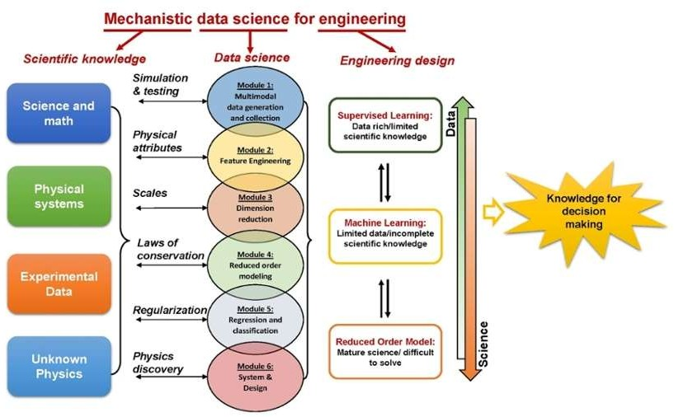

Manufacturers are always keen to adopt technology that improves product quality, reduces time- to-market, and is scalable across their units. Artificial Intelligence, Machine Learning, and Robotic Process Automation are helping manufacturers fine-tune product quality and optimize operation.

Mechanical engineer has many tasks to do in the organization be it in the production department, quality assessment department, sales and marketing and more. In any of the department automation can be implemented by making the use of machine learning and artificial intelligence

The objective of machine learning in business is not only for effective data collection, but to make use of the ever-increasing amounts being gathered by manipulating and analyzing it without heavy human input.

Machine intelligence enables complex and larger data to be processed and analyzed along with the desired results being achieved such as determining customer trends, detecting fraud, spotting buying trends and other primary objectives.

Machine learning in business therefore offers an important commercial benefit in being able to make the best use of your data.

Indeed, a key objective of machine learning is to enable you to keep up with those competitors already making best use of their data to maximize business opportunities.

Most commercial and non-commercial organizations benefit from machine learning, so it’s highly likely that some form of machine intelligence can be put to use in your business.

# Objective

*The purpose of machine learning is to discover patterns in your data and then make predictions based on often complex patterns to answer business questions, detect and analyses trends and help solve problems.*

*Machine learning in business and other fields is effectively a method of data analysis that works by automating the process of building data models.*

*Machine Learning brings many new and exciting approaches, especially for mechanical engineering. The efficiency, flexibility and quality of the systems can be significantly improved with the help of the available data. New business models for customers are developed. Machine Learning ensures that software and information technology are increasingly becoming the key drivers of innovation in mechanical engineering.*

*In many industries, the increasing interchangeability of individual machines will mean that in future not only the machine itself will be sold, but above all supplementary services. It also explains why machine learning is on the agenda in management and in many specialist areas of mechanical engineering companies.*

# THEORY

# Data Processing

Predictive causal analytics – If you want a model that can predict the possibilities of a particular event in the future, you need to apply predictive causal analytics.

Prescriptive analytics – If you want a model that has the intelligence of taking its own decisions and the ability to modify it with dynamic parameters, you certainly need prescriptive analytics for it. This relatively new field is all about providing advice.

Machine learning for making predictions — If you have transactional data of a finance company and need to build a model to determine the future trend, then machine learning algorithms are the best bet.

Machine learning for pattern discovery — If you don’t have the parameters based on which you can make predictions, then you need to find out the hidden patterns within the dataset to be able to make meaningful predictions. This is nothing but the unsupervised model as you don’t have any predefined labels for grouping

**Machine Learning – Categories of Machine Learning**

Machine learning evolved from left to right as shown in the above diagram.

* Initially, researchers started out with Supervised Learning. This is the case of the housing price prediction discussed earlier.
* This was followed by unsupervised learning, where the machine is made to learn on its own without any supervision.
* Scientists discovered further that it may be a good idea to reward the machine when it does the job the expected way and there came Reinforcement Learning.
* Very soon, the data that is available these days has become so humongous that the conventional techniques developed so far failed to analyse the big data and provide us the predictions.
* Thus, came the deep learning where the human brain is simulated in the Artificial Neural Networks (ANN) created in our binary computers.
* The machine now learns on its own using the high computing power and huge memory resources that are available today.
* It is now observed that Deep Learning has solved many of the previously unsolvable problems.
* 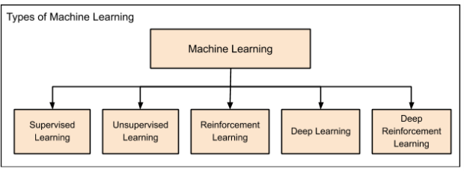The technique is now further advanced by giving incentives to Deep Learning networks as awards and there finally comes Deep Reinforcement Learning.

**Supervised learning** algorithms are trained using labelled examples, such as an input where the desired output is known. For example, a piece of equipment could have data points labelled either “F” (failed) or “R” (runs). The learning algorithm receives a set of inputs along with the corresponding correct outputs, and the algorithm learns by comparing its actual output with correct outputs to find

errors. It then modifies the model accordingly. Through methods like classification, regression, prediction and gradient boosting, supervised learning uses patterns to predict the values of the label on additional unlabeled data.

Supervised learning is commonly used in applications where historical data predicts likely future events. For example, it can anticipate when credit card transactions are likely to be fraudulent or which insurance customer is likely to file a claim.

**Unsupervised learning** is used against data that has no historical labels. The system is not told the "right answer." The algorithm must figure out what is being shown. The goal is to explore the data and find some structure within. Unsupervised learning works well on transactional data. For example, it can identify segments of customers with similar attributes who can then be treated similarly in marketing campaigns. Or it can find the main attributes that separate customer segments from each other. Popular techniques include self-organizing maps, nearest-neighbor mapping, k-means clustering and singular value decomposition.

These algorithms are also used to segment text topics, recommend items and identify data outliers.

**Semi supervised learning** is used for the same applications as supervised learning. But it uses both labelled and unlabeled data for training – typically a small amount of labelled data with a large amount of unlabeled data (because unlabeled data is less expensive and takes less effort to acquire). This type of learning can be used with methods such as classification, regression and prediction. Semi supervised learning is useful when the cost associated with labelling is too high to allow for a fully labelled training process. Early examples of this include identifying a person's face on a web cam.––

**Reinforcement learning** is often used for robotics, gaming and navigation. With reinforcement learning, the algorithm discovers through trial and error which actions yield the greatest rewards.

This type of learning has three primary components: the agent (the learner or decision maker), the environment (everything the agent interacts with) and actions (what the agent can do). The objective is for the agent to choose actions that maximize the expected reward over a given amount of time. The agent will reach the goal much faster by following a good policy. So the goal in reinforcement learning is to learn the best policy.

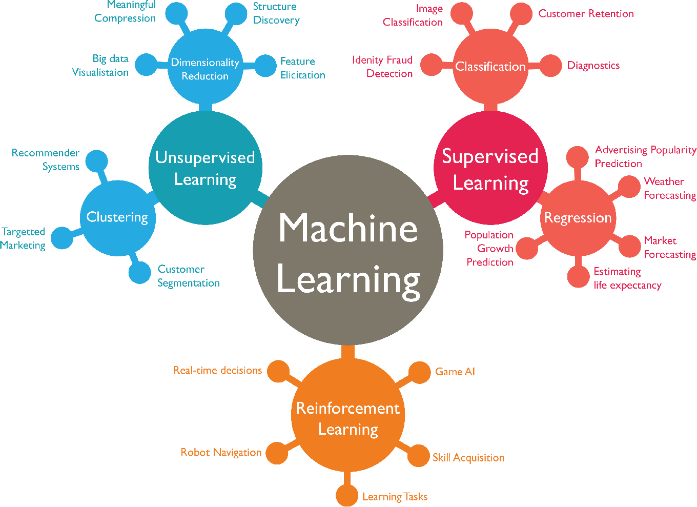

## ****Machine learning Components****

Key components of Data Science, which are:

* **Data (and Its Various Types)**

The raw dataset is the foundation of Data Science, and it can be of various types like structured data (mostly in a tabular form) and unstructured data (images, videos, emails, PDF files, etc.)

* **Programming (Python and R)**

Data management and analysis is done by computer programming.      
In Data Science, two programming languages are most popular:   
Python and R.

* **Statistics and Probability**

Data is manipulated to extract information out of it. The mathematical foundation of Data Science is statistics and probability. Without having a clear knowledge of statistics and probability, there is a high possibility of misinterpreting data and reaching at incorrect conclusions. That’s the reason why statistics and probability play a crucial role in Data Science.

* **Machine Learning**

As a Data Scientist, every day, you will be using Machine Learning algorithms such as regression and classification methods. It is very important for a Data Scientist to know Machine learning as a part of their job so that they can predict valuable insights from available data.

* **Sensors**

A sensor is a device that detects the change in the environment and responds to some output on the other system. A sensor converts a physical phenomenon into a measurable analog voltage (or sometimes a digital signal) converted into a human-readable display or transmitted for reading or further processing.

# METHODOLOGY

### Supervised Learning

**Linear Regression**

Regression analysis is a set of statistical methods used for the estimation of relationships between a dependent variable and one or more independent variables. It can be utilized to assess the strength of the relationship between variables and for modelling the future relationship between them.

Regression analysis includes several variations, such as linear, multiple linear, and nonlinear. The most common models are simple linear and multiple linear. Nonlinear regression analysis is commonly used for more complicated data set in which the dependent and independent variables show a nonlinear relationship. Regression analysis- simple linear regression.

Simple linear regression is a model that assesses the relationship between a dependent variable and an independent variable. The simple linear model is expressed using the following equation:

“Y=a + bX + ε”

Where:

* + Y- Dependent variable
  + X- Independent (explanatory) variable
  + a - Intercept
  + b - Slope
  + ε – Residual (Error)

**Multiple Linear Regression**

Multiple linear regression analysis is essentially similar to the simple linear model, with the exception that multiple independent variables are used in the model. The mathematical representation of multiple linear regression is:

## Y= a + bX1 + cX2 + dX3 + ε

Where:

* + Y- Dependent variable
  + X1, X2, X3- Independent (explanatory) variable
  + a - Intercept
  + b, c, d - Slope
  + ε – Residual (Error)

**Logistic regression**

Logistic regression is a [statistical model](https://en.wikipedia.org/wiki/Statistical_model) that in its basic form uses a [logistic function](https://en.wikipedia.org/wiki/Logistic_function) to model a [binary](https://en.wikipedia.org/wiki/Binary_variable) [dependent variable,](https://en.wikipedia.org/wiki/Dependent_variable) although many more complex [extensions](https://en.wikipedia.org/wiki/Logistic_regression#Extensions) exist. In [regression analysis,](https://en.wikipedia.org/wiki/Regression_analysis) logistic regression[[1]](https://en.wikipedia.org/wiki/Logistic_regression#cite_note-1) (or logit regression) is [estimating](https://en.wikipedia.org/wiki/Estimation_theory) the parameters of a logistic model (a form of [binary regression](https://en.wikipedia.org/wiki/Binary_regression)). Mathematically, a binary logistic model has a dependent variable with two possible values, such as pass/fail which is represented by an [indicator variable](https://en.wikipedia.org/wiki/Indicator_variable), where the two values are labelled "0" and "1".

C:\Users\kratos\Pictures\C1.JPGConsider a model with two predictors, *x1* and *x2*, and one binary (Bernoulli) response variable *Y*, which we denote *p=P(Y=1)*. We assume a linear relationship between the predictor variables and the log-odds (also called logit) of the event that *Y=1*. This linear relationship can be written in the following mathematical form (where *ℓ* is the log-odds, *b* is the base of the logarithm, and 𝛽𝑖 are parameters of the model).

We can recover the odds by exponentiating the log-odds:

C:\Users\kratos\Pictures\C2.JPG

**Unsupervised Learning**

**Kmeans Algorithm**

Kmeans Algorithm is an iterative algorithm that tries to partition the dataset into Kpre-defined distinct non-overlapping subgroups (clusters) where each data point belongs to only on group. It tries to make the intra-cluster data points as similar as possible while also keeping the clusters as different (far) as possible. It assigns data points to a cluster such that the sum of the squared distance between the data points and the cluster’s centroid (arithmetic mean of all the data points that belong to the cluster) is at the minimum. The less variation we have with the clusters, the more homogeneous(similar) the data points are within the same cluster.

The way kmeans algorithm works is as follows:

1. Specify number of clusters K.
2. Initiate centroids by first shuffling the dataset and then randomly selecting K data points for the centroids without replacement.
3. Keeping iterating until there is no change to the centroids. i.e assignment of data points to clusters isn’t changing.
   * Compute the sum of the squared distance between data points and all centroids.
   * Assign each data point to the closest cluster (centroid).
   * Compute the centroids for the cluster by the average of the all-data points that belongs to each cluster.

The approach kmeans follow to solve the problem is called Expectation-Maximization. The E-step is assigning the data points to the closet cluster. The M-step is computing the centroid of each cluster. Below is a breakdown of how we can solve it mathematically.

C:\Users\kratos\Pictures\C3.JPGThe objective function is:

Where,

**Wik**=1 for data point xi if it belongs to cluster k, otherwise,

**Wik** =0. Also, µk is the centroid of xi’s cluster.

it’s a minimization problem of two parts. We first minimize J w.r.t **Wik** and treat

**µk** fixed. Then we minimize J w.r.t **µk** and treak **Wik** fixed. Technically speaking, we differentiate J

w.r.t **Wik** first and update cluster assignments (E-step). Then we differentiate J w.r.t **µk** and recompute the centroids after the cluster assignment from previous step (M-step). Therefore, E-step is:

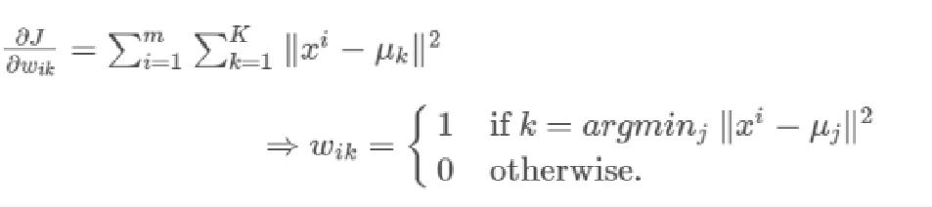

In other words, assign the data point xi to the closest cluster judged by its sum of squared distance from cluster’s centroid. And M-step is:

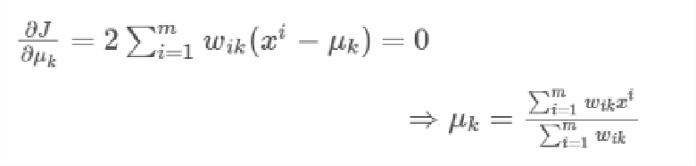

**PROGRAMS**

## 

## 

## 

## 

## 

## 

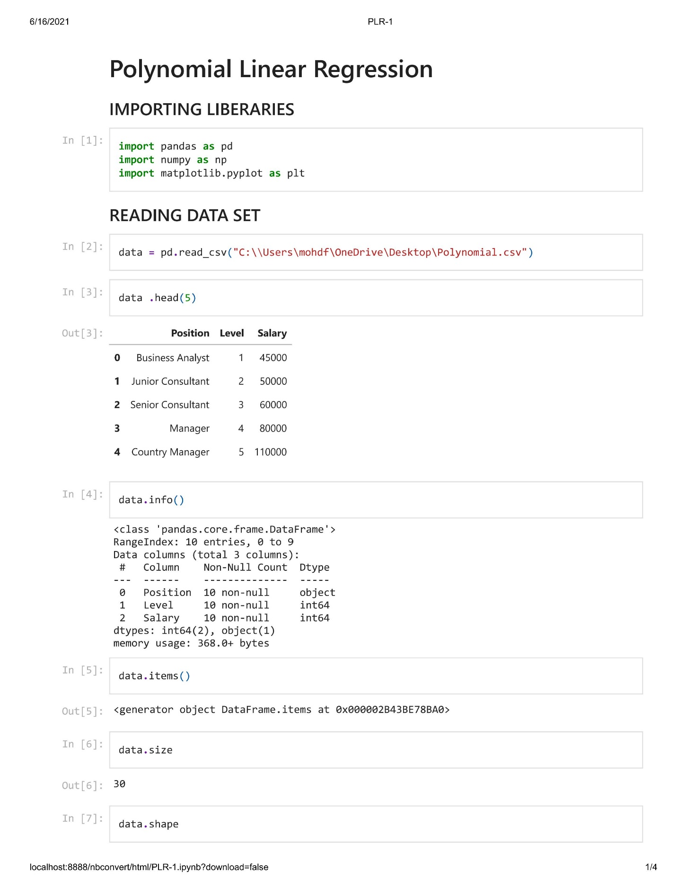

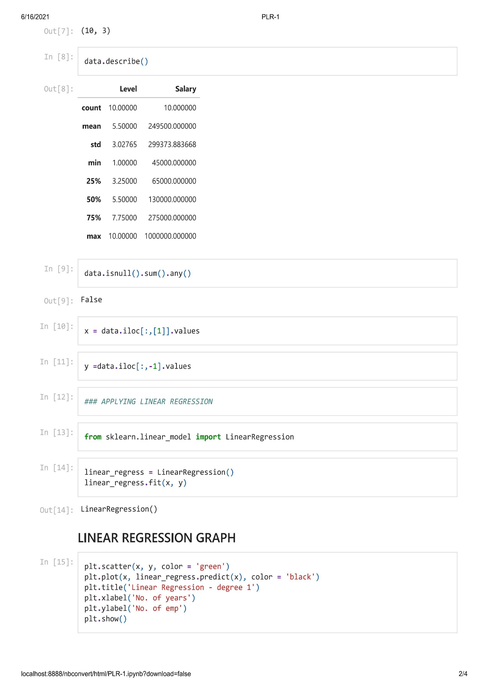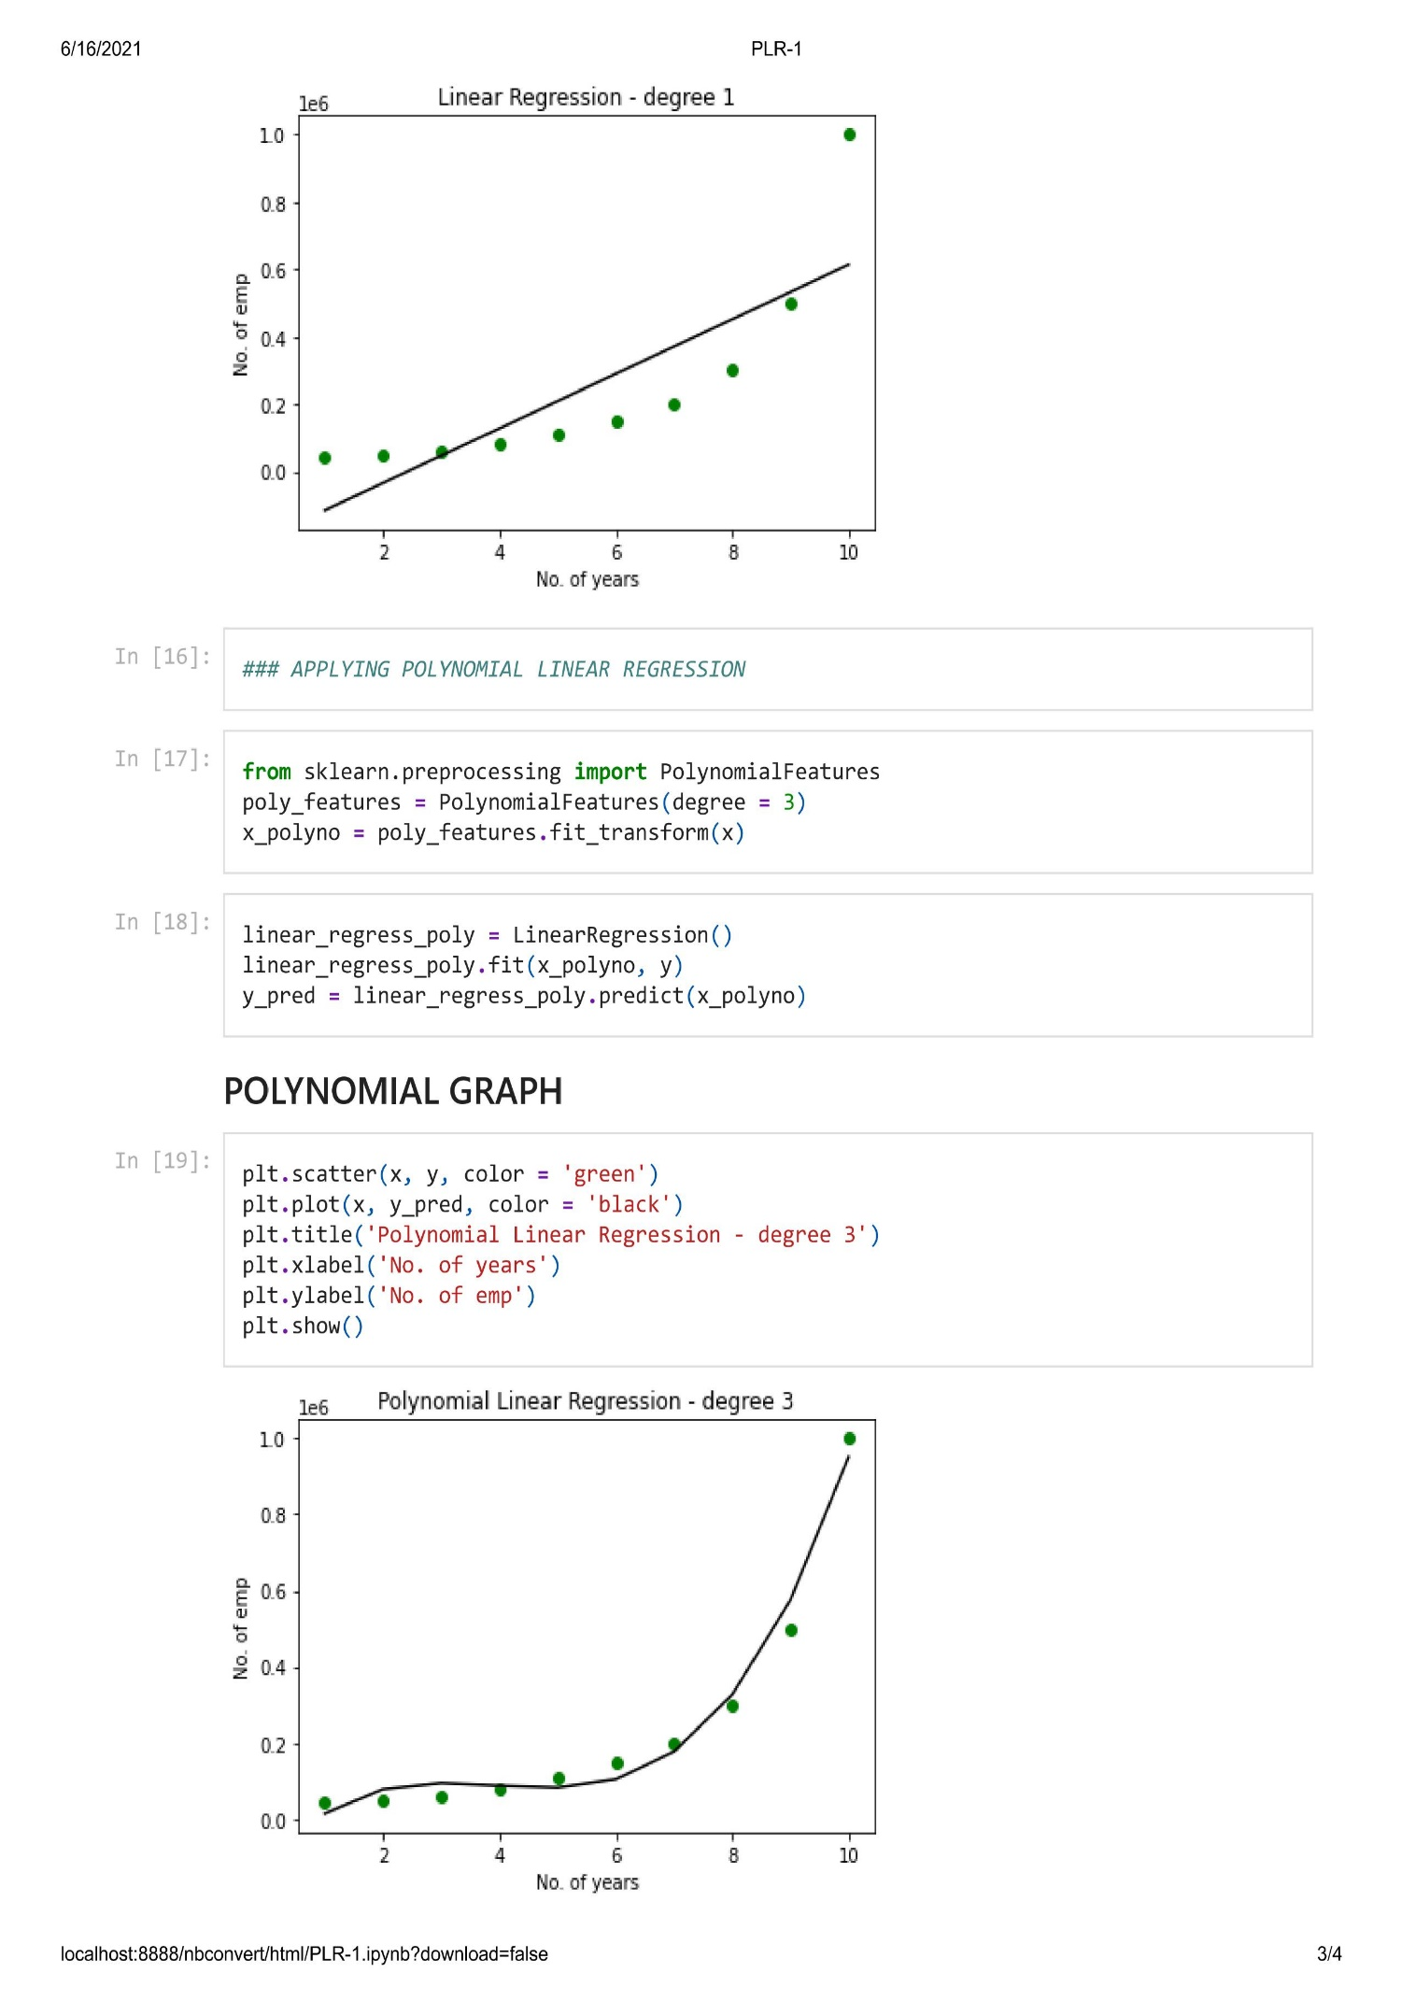

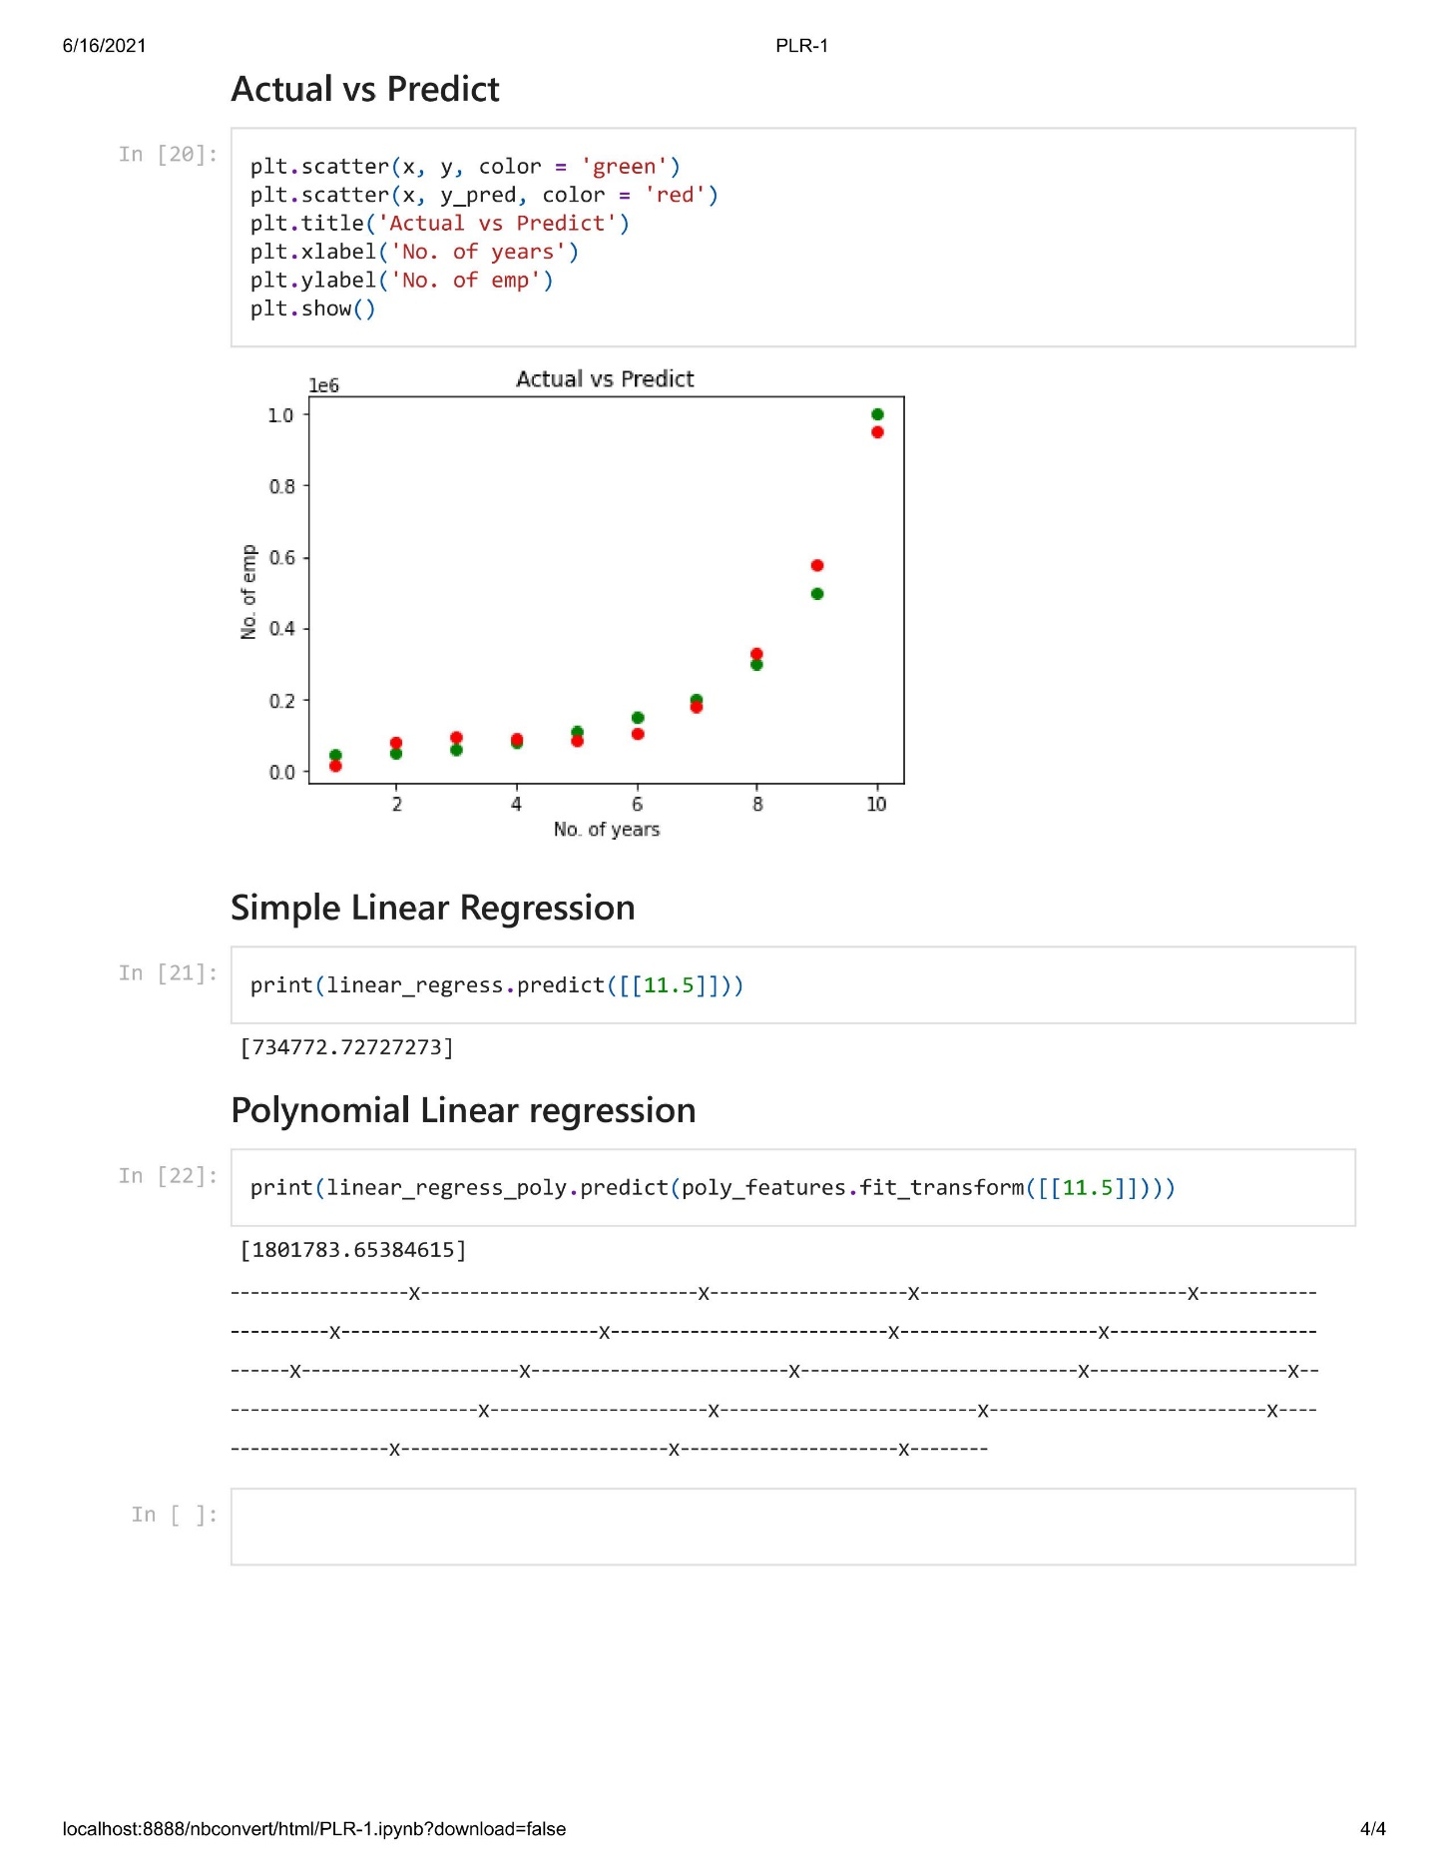

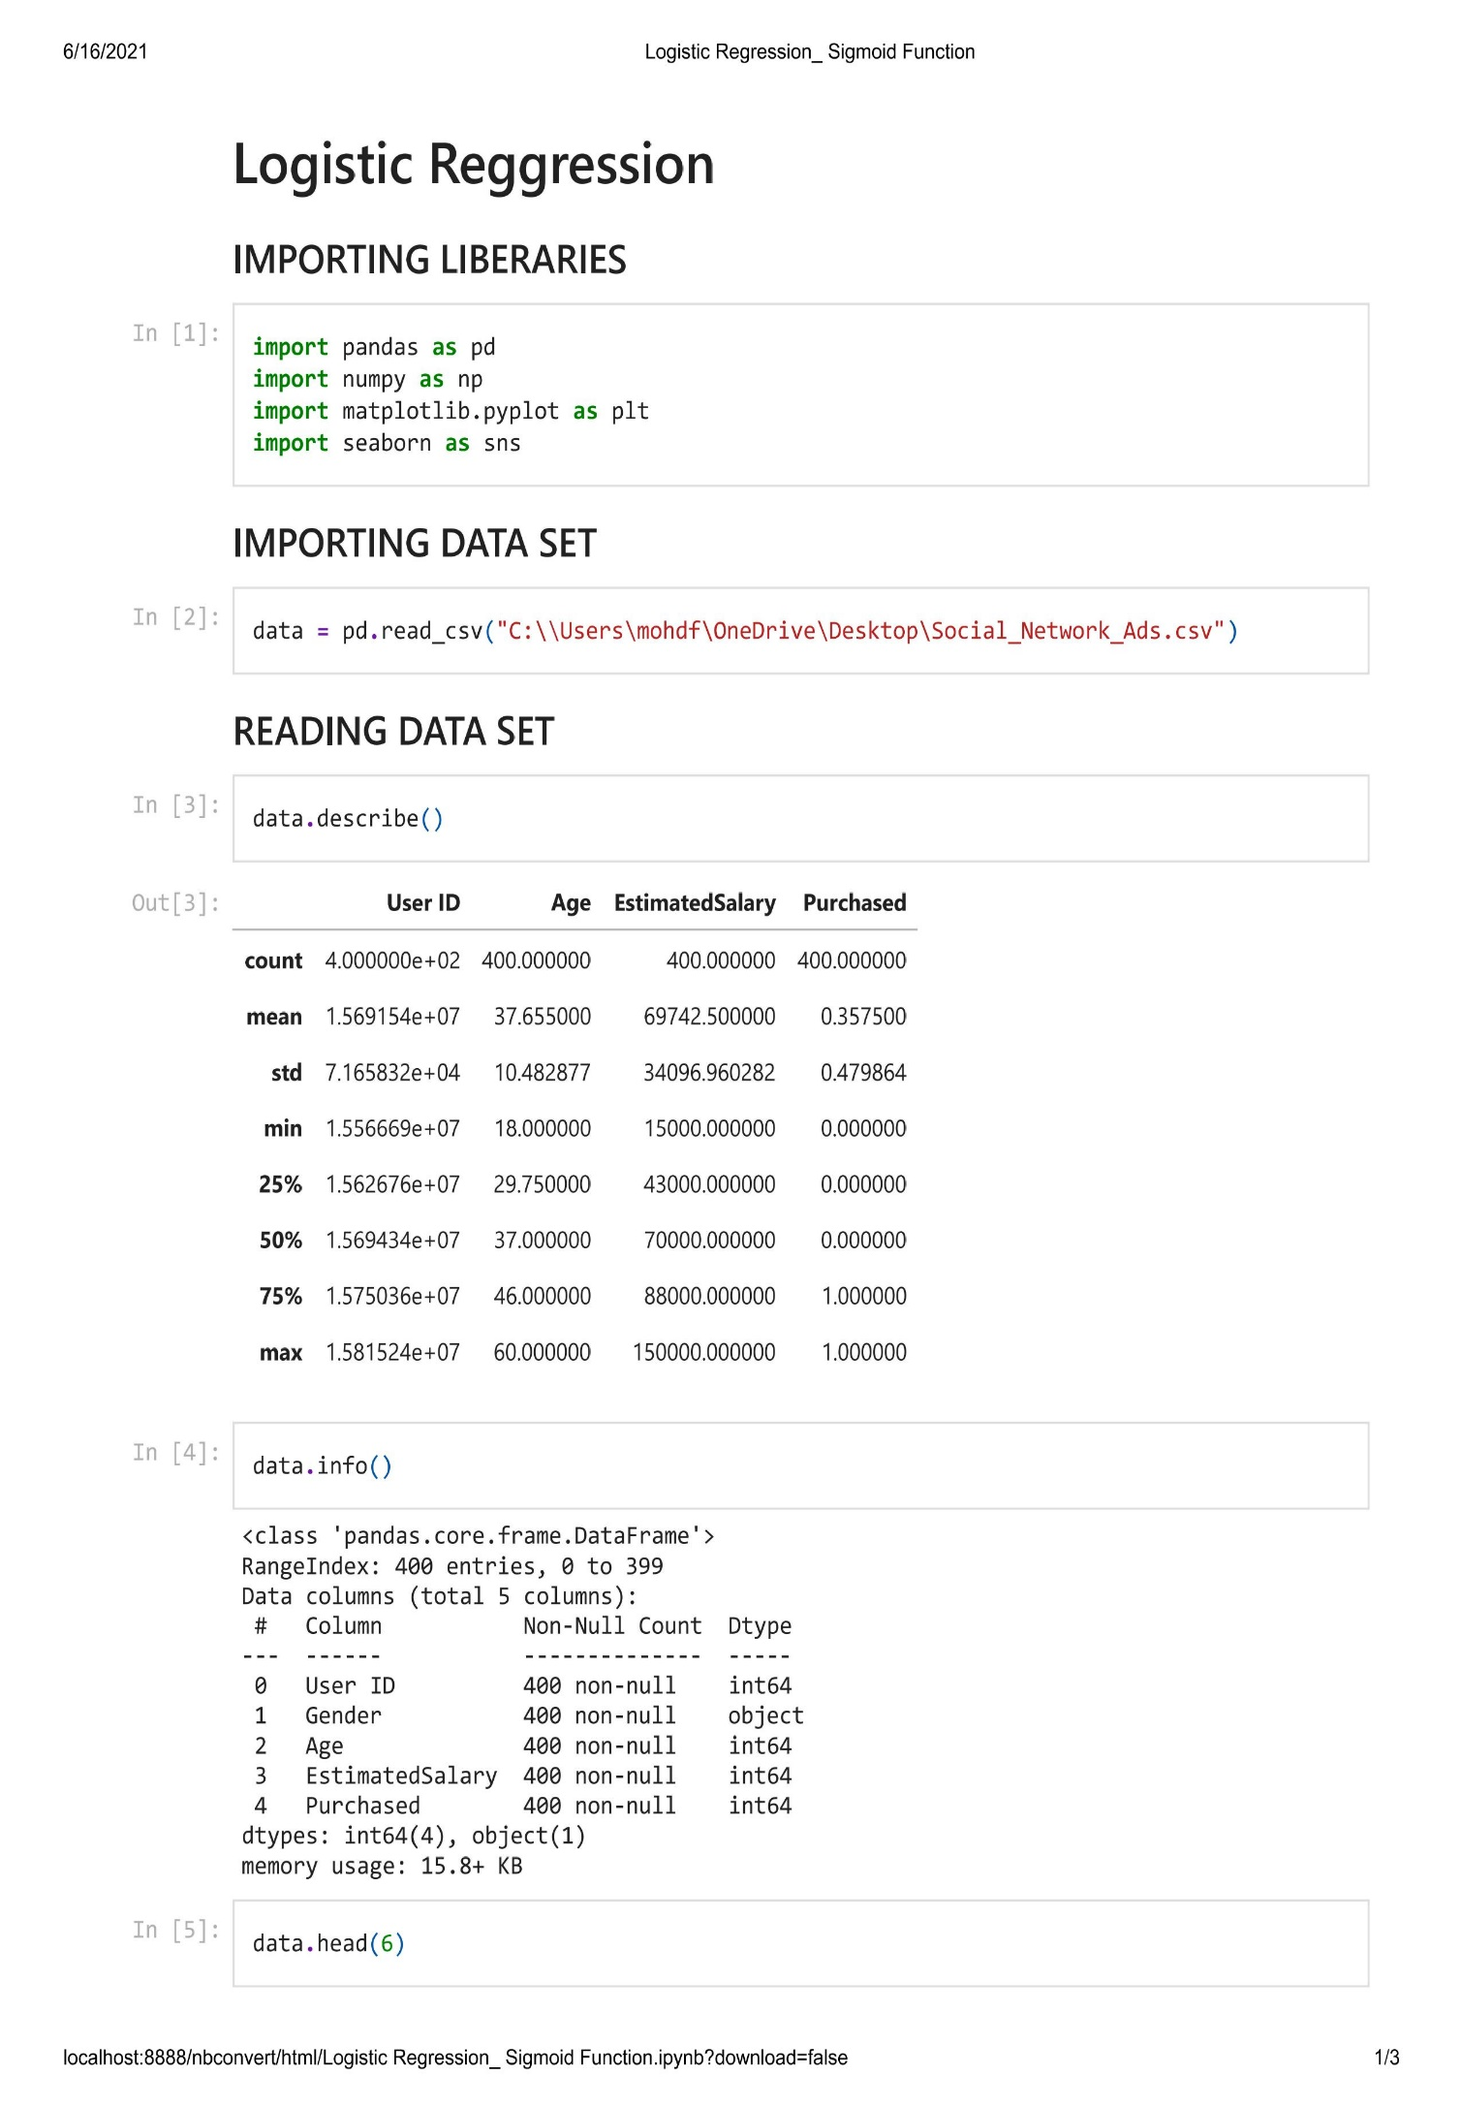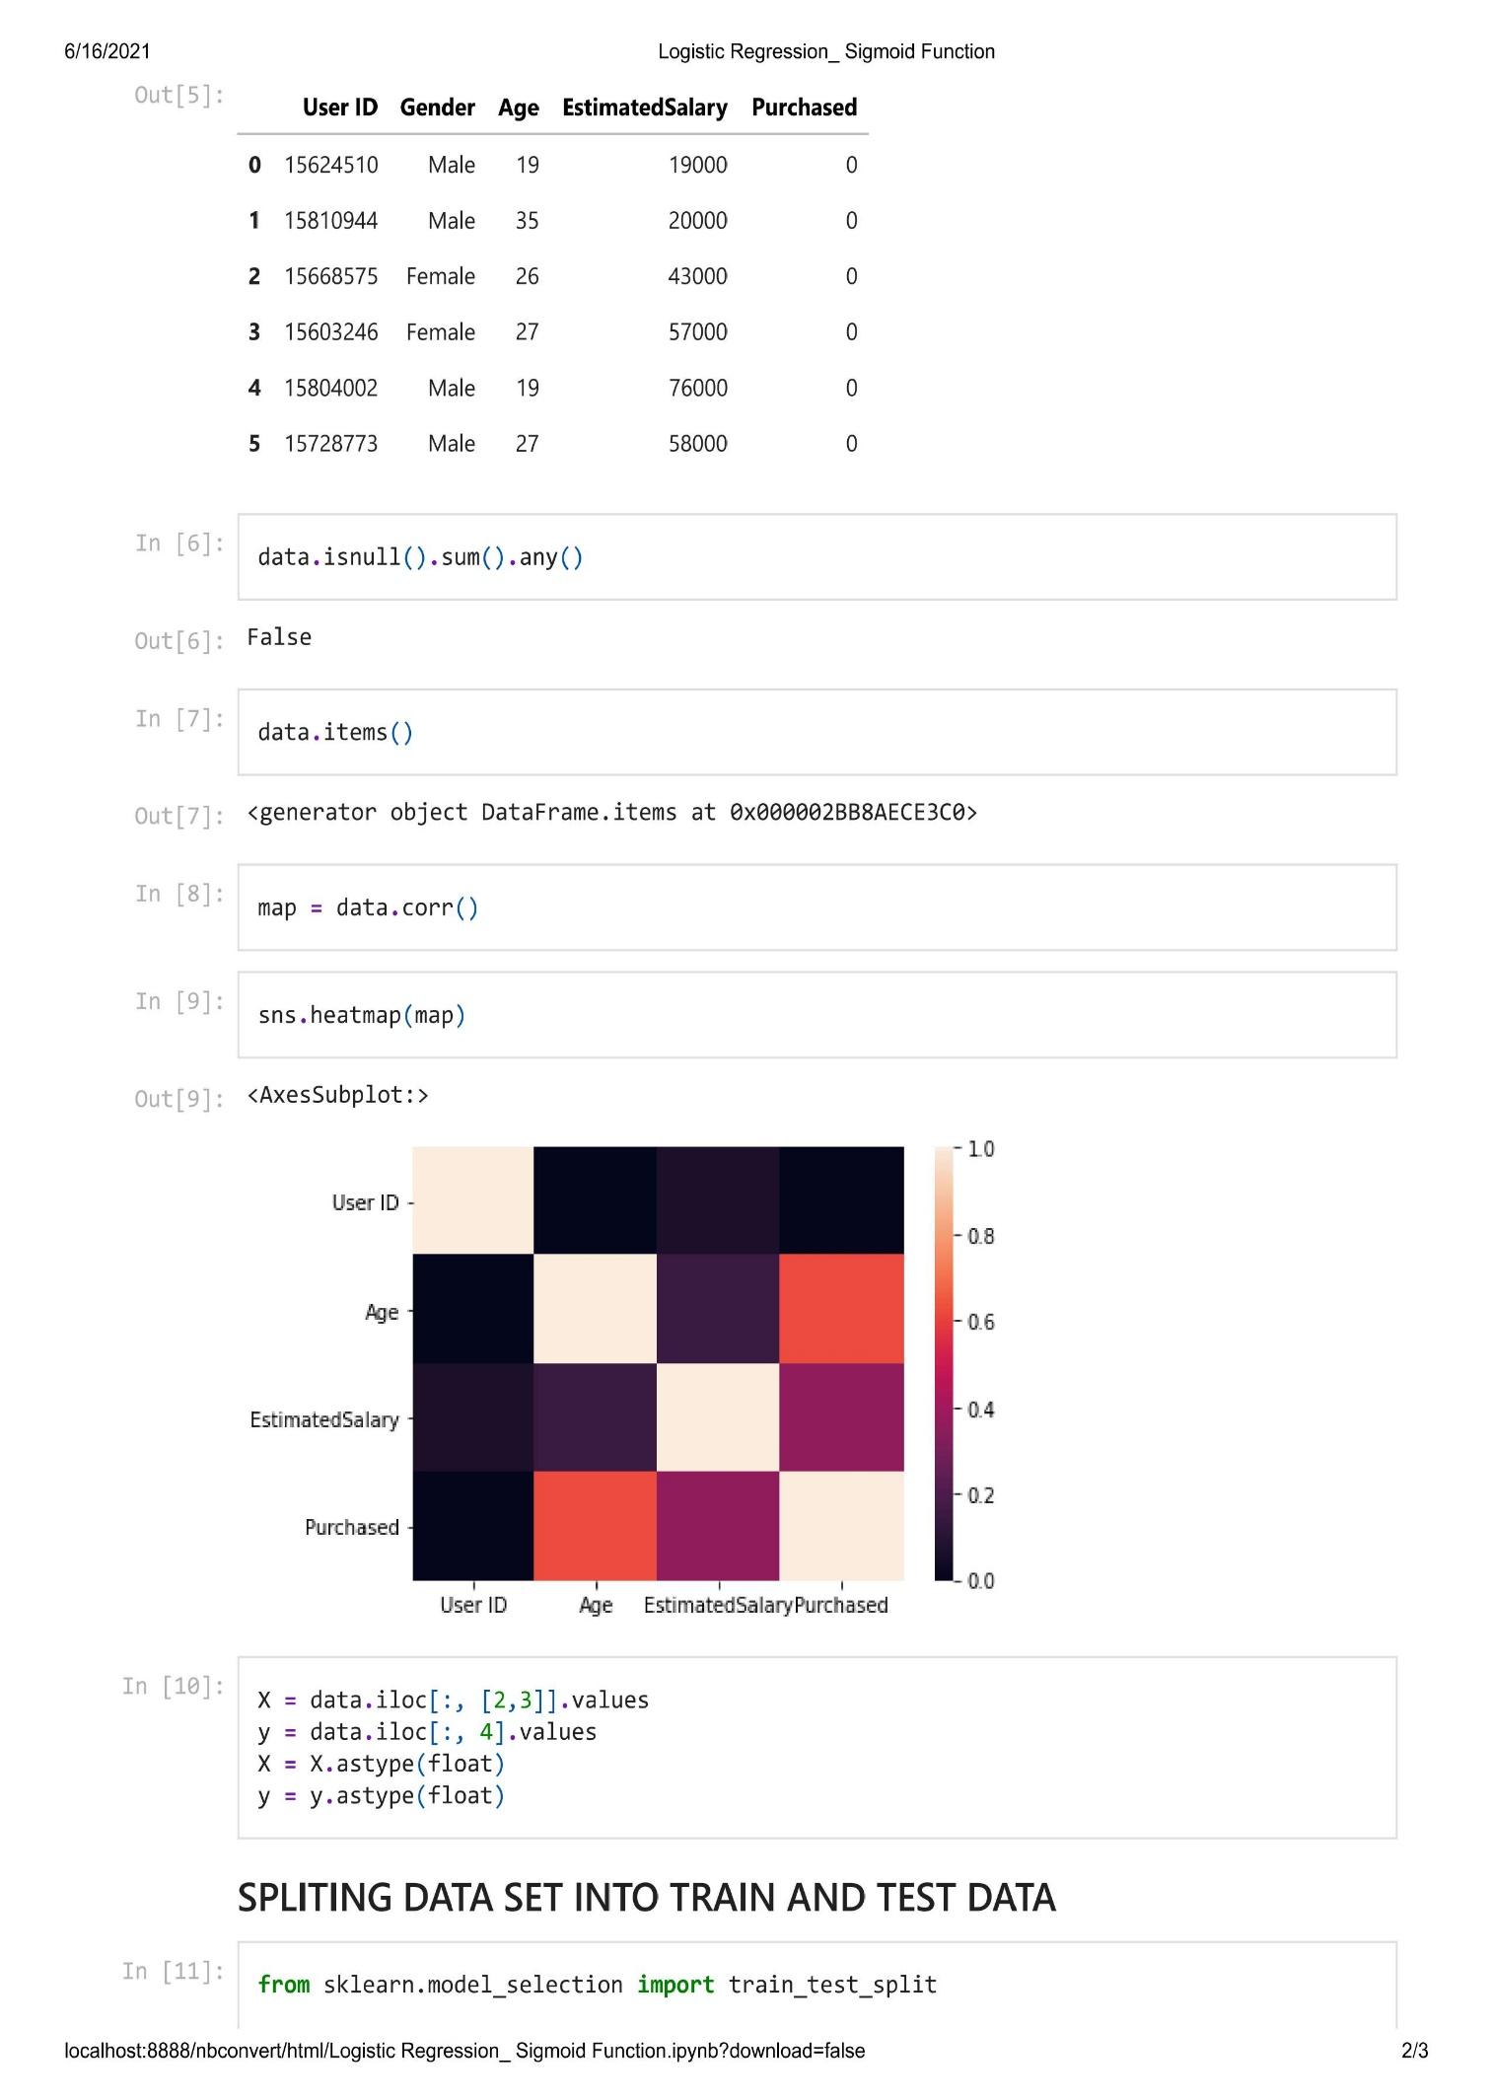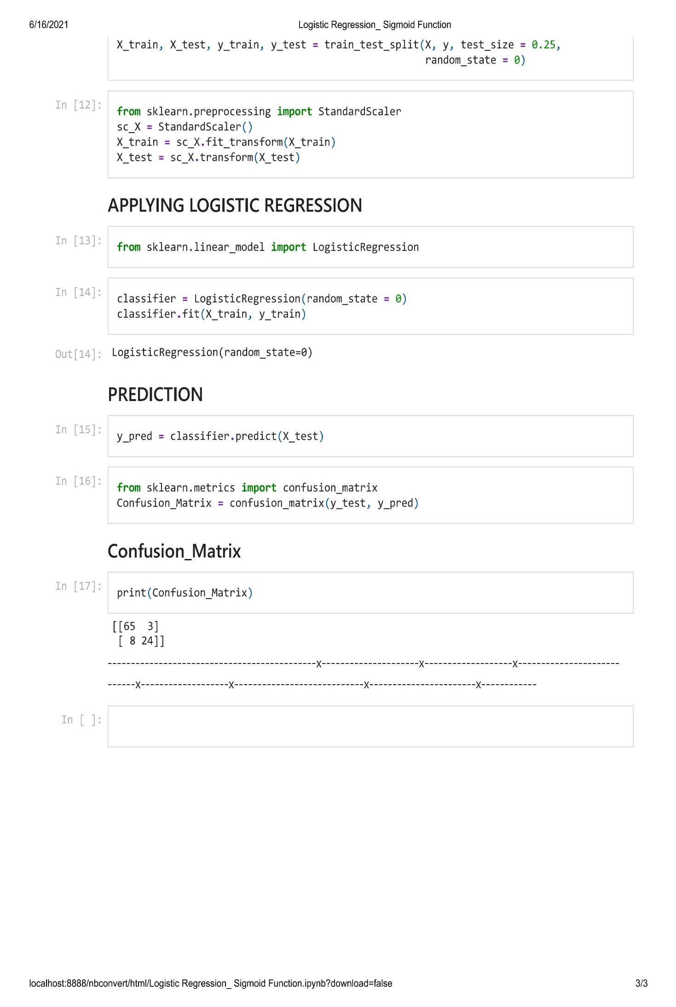

**Advantages of Machine Learning in Automation Industries**

Companies that don’t realize the importance of machine learning are doing a slow and resource-consuming job, which brings them back to the Middle Ages. They decrease the quality and speed of production by doing a lot of manual work and making human errors. This is what machine learning won’t let you do.

1. Improved Customer Experience Personalization: -

Machine learning will help you attract more people to your product or service and turn them into regular customers. You will be able to analyze customers’ browsing experience and behavior on your platform to offer them exactly what they need.

Suppose a recent search request of a user was “red sneakers”, and earlier they browsed middle-priced shoes of a specific brand. Based on this data, your platform will offer them all they were looking for. It will automatically create relevant recommendations of middle-priced red sneakers of a searched brand for this particular user.

Case in point, the recommendation engine running in Netflix helped the streaming service attract a vast audience and increase profits by effectively encouraging binge-watching. As of 2018, more than 80% of Netflix viewers watched shows following the recommendations enabled with machine learning.

On the overall, by personalizing customer experience with machine learning, you’ll get:

• bigger revenue due to higher customer engagement;

• increased customer satisfaction and, hence, higher brand loyalty;

• less time on research compared to the traditional methods of statistics;

• saved money on staff, office, and equipment.

2. Effective Work Processes Automation: -

Delegating manual and repetitive tasks to the machine increases the speed of production. At the same time, it helps to eliminate manual data entry errors and data duplication, ensuring the higher quality of work. Besides, you won’t need a developer to reprogram the system over again every time you want to change the workflow inside the company. By learning data continuously, your platform will be able to improve its performance and adjust work processes in the company without human assistance.

Thus, by automating business processes with machine learning, you will:

• make products and/or provide services faster;

• cut expenses on software maintenance;

• save money on staff by delegating workload to machines;

• save time on finding human resources to do the job;

• make high-quality products by removing human error;

• reduce administrative tasks and paperwork, etc.

3. Powerful Predictive Ability: -

While some companies use the predictive powers of ML and know what they can do to improve products or services in advance, their competitors that use traditional statistical methods stay at the research stage. There are two ways you can benefit from the ML predictions:

• Customer choice predictions. Based on customer data, the machine learning system recognizes typical and atypical behavior patterns. With this information, you can predict the changing demands for your products, features, or services and build the most effective marketing strategies to grow sales. Moreover, by knowing people’s preferences, you will understand the exact amount of time and material resources to use in production.

• Market change forecast. Large enterprises can get their systems programmed to process enormous market data and provide forecasts on upcoming innovations or changes. Consequently, you will be able to use trends faster than your competitors and predict business risks considering important market events.

As a result, the ML predictions will let you:

• know trends before your competitors;

• save time and money resources for production and promotion;

• build long-term relationships with customers;

• increase customer engagement and satisfaction;

• push powerful sales strategies to make bigger profits;

• understand how to keep your business on the run within global changes.

4. Reasonable Resource Planning: -

Based on the predictions obtained via machine learning, a company can estimate the resources required to meet changing demands for its products or services. Knowing in advance what your customers expect from your company in the near future will help you in inventory and process management.

Using machine learning for resource planning will allow you to:

• save money on supplies by knowing the right amount of product to keep on hand;

• set work responsibilities wisely by understanding the exact amount of work to do;

• have enough products, even during high sales growth period;

• decrease the risk of waste materials.

5. Easy Changes within Company: -

The scope of ML benefits isn’t limited to customer acquisition and marketing campaigns. You can set and manage workflow, follow staff progress, and maintain corporate values inside your company more efficiently. Any time you want to change something within your workspace, the system will be able to adopt all the changes quickly and reorganize the existent business processes.

Thus, with a machine learning solution, your company will get:

• faster adaptation to changing work processes;

• wiser task prioritization and division between workers;

• higher transparency of work processes among employees;

• better productivity due to measuring staff behavior in the workplace;

• easier integration of new technologies into the existing system.

6. Fast Adaptation to Market Changes: -

Large enterprises like Google, Apple, or Amazon are game-changers in the global market, so many companies follow their activity to understand how they can improve their business. The ML predictions give you a competitive advantage over other companies by letting you know beforehand how large companies will influence the market and what products and services will be relevant according to their activity.

So, ML will help your business stay marketable by:

• providing insights into market movement and letting you know global trends in advance;

• ensuring the basis for efficient sales and marketing strategies in the future;

• helping you manage time, money, and human resources ahead of time;

• letting you adapt to changing business environment faster and easier.

7. Advanced Customer Support: -

The ML solutions help to improve customer relationship management because it makes chatbots and voice assistants’ implementation possible. With these technologies, your own customers take an active part in service improvement, because systems learn directly from your customers when they enter text or say something to chatbots or voice assistants.

The benefits of customer support enabled with ML are:

• 24/7 available customer service from all corners of the world;

• saved time on introducing products to customers by automated FAQ answering;

• reduced cost of human labor because the initial communication is delegated to bots;

• improved customer engagement, since people tend to prefer chats over live conversations.

8. Increased Data Security: -

The security of the company and its customers has always been essential for successful business development. For instance, PayPal uses ML to ensure payment security. By noticing changes in data on financial transactions, such as sender and recipient information, credit card activity, date and time of the transaction, amount of payment, etc. the PayPal system is able to detect financial fraud.

Machine learning is used for face recognition to ensure a higher level of security. You can see this feature on Facebook when you are tagging someone in the picture or asked to authorize by the system in case it noticed suspicious activity on your profile. In medicine, ML helps hospitals keep patient’s health information confidential and available for attending physicians.

Thus, by increasing the security of your data with ML, you get:

• eliminated fraudulent actions related to financial and personal data usage;

• increased customer trust by keeping their information confidential;

• reduced information leaks within the company.

9. More Productive Staff Training: -

Machine learning improves staff productivity and the quality of staff in companies. It eases the onboarding of new employees and helps your regular workers train their professional skills.

For example, if your company provides consulting services, you can set an AI/ML system

to simulate real conversations with clients. During the probation period at work, these systems can educate your workers and help them become more confident and competent in customer service.

Consequently, the advantages you can use at this point are:

• faster staff onboarding;

• improved competence of employees;

• saved time and money compared to human mentorship programs;

• higher quality of customer service, hence, increased customer satisfaction;

• better productivity of regular employees since they are more focused on work rather than mentoring newcomers.

10. Efficient Data Management: -

Growing volumes of data that companies collect and use each day become difficult to manage. Machine learning helps to separate relevant data from peripheral information and spam. This is how Google Gmail works. Google uses the TensorFlow ML library that, as of 2019, helped to eliminate 100 million spam messages per day, so people don’t have their inbox clogged up.

So, in terms of data management, machine learning will help you to:

• save time by dividing important and peripheral work data for your employees;

• make your staff more productive since employees concentrate on higher priority tasks;

• drive higher user engagement by offering customers only relevant information, etc.

# Application Of Machine Learning in Automation

# Next-generation optimization for manufacturers with Machine Learning

The two major use cases of Machine Learning in manufacturing are Predictive Quality & Yield, and Predictive Maintenance.

**Predictive Maintenance** is the more commonly known of the two, given the significant costs maintenance issues and associated problems can incur, which is why it is now a fairly common goal amongst manufacturers.

Instead of performing maintenance according to a predetermined schedule or using SCADA systems set up with human-coded thresholds, alert rules and configurations, predictive maintenance uses algorithms to predict the next failure of a component/machine/system.

Personal can then be alerted to perform focused maintenance procedures to prevent the failure, but not too early so as to waste downtime unnecessarily. By contrast, traditional manual and semi-manual approaches don’t take into account the more complex dynamic behavioral patterns of the machinery, or the contextual data relating to the manufacturing process at large. For example, a sensor on a production machine may pick up a sudden rise in temperature. A static rule-based system would not take into account the fact that the machine is undergoing sterilization and would proceed to trigger a false-positive alert.

The advantages are numerous and can significantly reduce costs while eliminating the need for planned downtime in many cases.

By preempting a failure with a machine learning algorithm, systems can continue to function without unnecessary interruptions. When maintenance is needed, it’s very focused – technicians are informed of the components that need inspection, repair and replacement; which tools to use, and which methods to follow.

Predictive maintenance also leads to a longer Remaining Useful Life (RUL) of machinery and equipment since secondary damage is prevented while smaller labour forces are needed to perform maintenance procedures.

**Predictive Quality and Yield** — sometimes referred to as just “Predictive Quality” — is a more advanced use case of Industrial Artificial Intelligence, that reveals the hidden causes of many of the perennial process-based production losses manufacturers face on a daily basis. Examples include quality, yield, waste, throughput, energy efficiency, emissions, and more — essentially any loss caused by process inefficiencies.

Predictive Quality and Yield automatically identifies the root causes of process-driven production losses using continuous, multivariate analysis, powered by Machine Learning algorithms that are uniquely trained to intimately understand each individual production process.

Automated recommendations and alerts can then be generated to inform production teams and process engineers of an imminent problem, and seamlessly share important knowledge on how to prevent the losses before they happen.

Reducing these types of losses has always been a struggle for manufacturers of all stripes. But in today’s marketplace, this mission is more important than ever before.

On the one hand, consumers’ expectations are higher than ever before; global consumer habits are gradually “westernizing”, even as the population boom continues. According to numerous surveys, the global population will grow by 25% by 2050, equating to some 200,000 additional mouths to feed every day. On the other hand, consumers have never had so many alternatives available to them, in almost every product imaginable. Recent

surveys indicate that this wealth of options means consumers are increasingly likely to permanently ditch even their favorite brands if, for example, a product isn’t available on the shelf.

Against such a backdrop, manufacturers can no longer afford to take process inefficiencies, and their associated losses, in their stride. Every loss in terms of waste, yield, quality or throughput chips away at their bottom line and hands another inch to the competition.

The challenge for many manufacturers is that they eventually hit a glass ceiling in terms of process optimization. Some inefficiencies don’t have any obvious cause, and process experts are left at a loss to explain them. That’s where Machine Learning — and particularly Automated Root Cause Analysis — can really save the day.

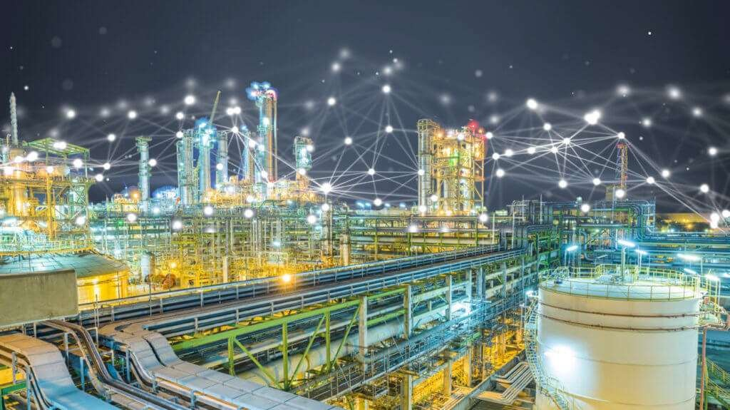

#### Main categories of Machine Learning — and how they relate to manufacturing

Machine Learning can be split into two main techniques – Supervised and Unsupervised machine learning.

#### Supervised Machine Learning

In manufacturing use cases, supervised machine learning is the most commonly used technique since it leads to a predefined target: we have the input data; we have the output data; and we’re looking to map the function that connects the two variables.

Supervised machine learning demands a high level of involvement – data input, data training, defining and choosing algorithms, data visualizations, and so on. The goal is to construct a mapping function with a level of accuracy that allows us to predict outputs when new input data is entered into the system.

Initially, the algorithm is fed from a training dataset, and by working through iterations, continues to improve its performance as it aims to reach the defined output. The learning process is completed when the algorithm reaches an acceptable level of –accuracy.

In manufacturing, there are two most common Supervised Learning approaches:

#### Classification and Regression

These 2 approaches share the same goal: to map a relationship between the input data (from the manufacturing process) and the output data (known possible results such as quality or waste losses, part failure, overheating etc.)

**Regression**

Regression is used when data exists within a range (e.g. temperature, weight), which is often the case when dealing with data collected from sensors.

In manufacturing, regression can be used to calculate an estimate for the Remaining Useful Life (RUL) of an asset. This is a prediction of how many days or cycles we have before the next component/machine/system failure.

For regression, the most commonly used machine learning algorithm is Linear Regression, being fairly quick and simple to implement, with output that is easy to interpret. An example of linear regression would be a system that predicts temperature, since temperature is a continuous value with an estimate that would be simple to train.

#### Classification

When data exists in well-defined categories, Classification can be used. An example of Classification that we’re all familiar with is the email filter algorithm that decides whether an email should be sent to our spam folder, or not. Classification is limited to a Boolean value response but can be very useful since only a small amount of data is needed to achieve a high level of accuracy.

In machine learning, common Classification algorithms include naive Bayes, logistic regression, support vector machines and Artificial Neural Networks.

#### Unsupervised Machine Learning

With Supervised machine learning we start off by working from an expected outcome and train the algorithm accordingly. Unsupervised learning is suitable for cases where the outcome is not yet known.

#### Clustering

In some cases, not only will the outcome be unknown to us, but information describing the data will also be lacking (data labels). By creating clusters of input data points that share certain attributes, a Machine Learning algorithm can discover underlying patterns.

Clustering can also be used to reduce noise (irrelevant parameters within the data) when dealing with extremely large numbers of variables.

#### Artificial Neural Networks

In the manufacturing sector, Artificial Neural Networks are proving to be an extremely effective unsupervised learning tool for a variety of applications including production process simulation and Predictive Quality Analytics.

The basic structure of the Artificial Neural Network is loosely based upon how the human brain processes information using its network of around 100 billion neurons, allowing for extremely complex and versatile problem solving.

A basic schematic of a feed-forward Artificial Neural Network. Every node in one layer is connected to every node in the next. Hidden layers can be added as required, depending on the complexity of the problem.

This ability to process a large number of parameters through multiple layers makes Artificial Neural Networks very suitable for the variable-rich and constantly changing processes common to manufacturing. Moreover, once properly trained, an Artificial Neural Network can demonstrate a high level of accuracy when creating predictions regarding the mechanical properties of processed products, enabling cuts in the cost of raw materials.

#### Data Preparation

Machine learning is all about data, so understanding some key elements about the quality and type of data needed is extremely important in ensuring accurate results.

With Predictive Quality and Yield, for example, we’re focused on process inefficiencies. Therefore, it makes sense to start by collecting historical data about the performance of the line or lines in question, as well as the losses incurred over time, in order to form predictions about future potential losses.

To get the fullest, most accurate picture possible, that data should be gathered from as many sources as possible, since manufacturing processes – especially more complex ones

– are affected by a very wide range of factors that are often interdependent. This can include everything from process data, quality data, raw materials, and even external factors like weather and temperature.

Next, and just as importantly, we need to decide what question we want the Machine Learning model to answer – and whether it is possible to answer this question using the data that’s available.

#### The Groundbreaking Benefits of Machine Learning and AI for Manufacturing

The introduction of AI and Machine Learning to industry represents a sea change with many benefits that can result in advantages well beyond efficiency improvements, opening doors to new business opportunities.

Some of the direct benefits of Machine Learning in manufacturing include:

* Reducing common, painful process-driven losses e.g. yield, waste, quality and throughput
* Increased capacity by optimizing the production process
* Enabling growth and expansion of product lines at scale due to a more optimized process
* Cost reduction through Predictive Maintenance. PdM leads to less maintenance activity, which means lower labor costs and reduced inventory and materials wastage.
* Predicting Remaining Useful Life (RUL). Knowing more about the behavior of machines and equipment leads to creating conditions that improve performance while maintaining machine health. Predicting RUL does away with “unpleasant surprises” that cause unplanned downtime.
* Improved supply chain management through efficient inventory management and a well monitored and synchronized production flow.
* Improved Quality Control with actionable insights to constantly raise product quality.
* Improved Human-Robot collaboration improving employee safety conditions and boosting overall efficiency.
* Consumer-focused manufacturing – being able to respond quickly to changes in the market demand.

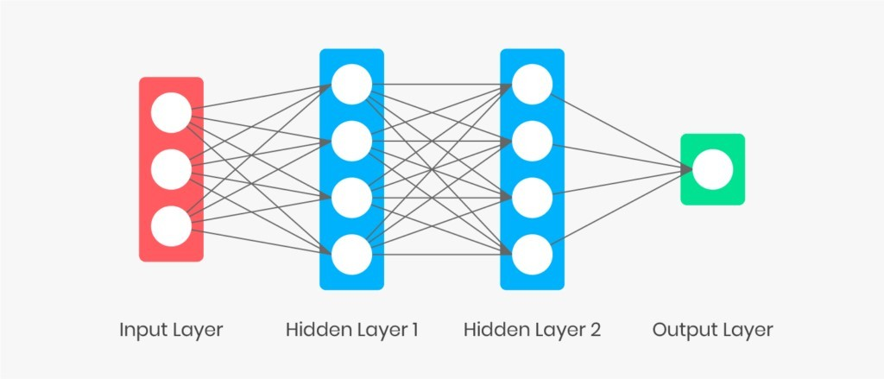

**Techniques of machine tool monitoring**

Machine tool monitoring can be done with or without additional sensors. Using additional sensors, monitoring can be done by measuring:

1. the cutting force (with a multi-channel table dynamometer or rotating dynamometer)
2. vibration amplitude using multi-channel accelerometers
3. audible sound from the machining process
4. high-frequency sound or acoustic emission

Sensor-less machine tool monitoring is done by measuring internal drive signals such as:

* feed motor current
* spindle motor current
* spindle power
* Combined measuring of multiple quantities is also possible.

**Acoustic emission sensor**

Machine tool monitoring is explained with Acoustic Emission (AE) sensors. An AE sensor is commonly defined as the sound emitted as an elastic wave by a solid when it is deformed or struck, caused by the rapid release of localized stress energy. Therefore, it is an occurrence phenomenon which releases elastic energy into the material, which then propagates as an elastic wave. The detection frequency range of acoustic emission is from 1 kHz to 1 MHz

Rapid stress-releasing events generate a spectrum of stress waves starting at 0 Hz and typically falling off at several MHz AE can be related to an irreversible release of energy. It can also be generated from sources not involving material failure including friction, cavitation and impact. The three major applications of AE sensors phenomena are: a) Source location - determine the locations of occurrence of an event b) Material mechanical performance - evaluate and characterize materials/structures; and c Health monitoring – monitors the safety operation.

**How an AE sensor monitors machine tool?**

An AE sensor works on the principle of measuring the high-frequency energy signals produced during cutting process. It also measures the AE energy resulting from the fracture when a tool break. It is best suited to applications where the level of background AE signal is low compared to the sound of tool breakage. This makes the AE sensor ideal for breakage detection of small drills and taps. It is easy to install on both new and existing machines.

An AE sensor detects force proportional monitoring signals even in machining operations, which generate very small cutting forces. In combination with true power, it increases the reliability of breakage monitoring. It is used especially with solid carbide tools, or very small tools on large machines and multi spindles. Most of the sensors have to be attached to the machine tool surface. However, there are alternative methods of AE wave transmitting. A rotating, wireless AE sensor consists of a rotating sensor and a fixed receiver. An AE sensor can also receive the acoustic waves via a jet of cooling lubricant, which can be connected directly to the tool or workpiece.

The machine tool monitoring systems commonly use sensors for measuring cutting force components or quantities related to cutting force (power, torque, distance/displacement and strain). AE sensors are relatively easy to install in existing or new machines, and do not influence machine integrity and stiffness. All systems suppliers also use acoustic emission sensors, especially for monitoring small tools and for grinding.

All sensors used in machine tool monitoring systems are well adjusted to harsh machine tool environments. The difficulties in designing reliable machine tool monitoring can be related to the complexity of the machining process itself, which may have one or more of the following characteristics, apart from the changes of the machine tool itself.

**Types of Sensors**

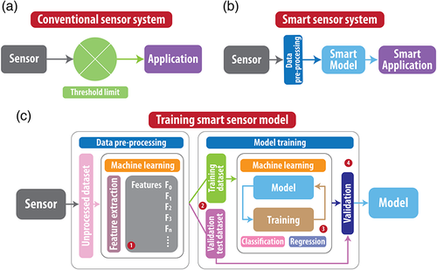

There are many types of sensors that have been invented to measure physical phenomenon:

* **Thermocouples, RTDs and Thermistors**: for measuring temperature
* **Strain gages**: to measure strain on an object, e.g. pressure, tension, weight, etc.,
* **Load cells**: for measuring weight and load
* **LVDT sensors**: LVDTs are used to measure displacement in distance
* **Accelerometers**: measuring vibration and shock
* **Microphones**: for capturing sound waves
* **Current transducers**: for measuring AC or DC current
* **Voltage transformers**: for measuring high voltage potentials
* **Optical sensors**: used to detect light, transmit data, and replace conventional sensors
* **Camera sensors**: used to capture single and continuous 2D images
* **Digital sensors**: used for discrete on/off counting, linear and rotary encoding, position measurements, etc.
* **Positioning sensors (GPS)**: used to capture the longitudinal, latitudinal position based on GPS, GLONASS, and other satellite positioning systems. Different GPS sensors with different accuracy are available.
* and countless more.

Depending on the type of sensor, its electrical output can be voltage, current, resistance, or another electrical attribute that varies over time. Some sensors are available with digital outputs, whereby they output a series of bytes of scaled or unscaled data. The output of these analog sensors is typically connected to the input of a signal conditioner, which we will discuss in the next section.

# CONCLUSION

The easy availability of High-Performance Computing (HPC) has resulted in a sudden increased demand for IT professionals having Machine Learning skills.

##### This paper has presented the synopsis of our Major Project, i.e. Machine Learning. It has shown all the required information about the introduction, objective, plan, advantages and application of the project.

*Machine learning offers numerous advantages to small and mid-size companies as well as large enterprises by providing them with:*

* *an efficient solution for business process automation;*
* *a technology that saves a considerable amount of time, money and human resources;*
* *a helpful tool providing with customer preference insights and market forecasts;*
* *a marketing instrument for customer experience personalization;*
* *a reliable tool for monitoring transactions and detecting fraud in the Fintech industry;*
* *a utility that helps with patient diagnostics in healthcare, and more.*

*Various industries appreciate this technology for predictive powers, resource-saving capabilities, and efficient customer management that allow companies to avoid as many mistakes as possible in their business.*

*We would like to extend our sincere gratitude to Dr. Deepak Bharadwaj for guiding us in our project. We would also like to appreciate the immense support provided by our honorable HOD Sir and other faculty members who are always there to guide us and help us in the time of need.*

**FUTURE SCOPE**

The scope of Machine Learning is not limited to the investment sector. Rather, it is expanding across all fields such as banking and finance, information technology, media & entertainment, gaming, and the automotive industry. As the Machine Learning scope is very high, there are some of the areas where researchers are working toward revolutionizing the world for the future. Let us discuss them in detail.

### Automotive Industry

The automotive industry is one of the areas where Machine Learning is excelling by changing the definition of ‘safe’ driving. There are a few major companies such as Google, Tesla, Mercedes Benz, Nissan, etc. that have invested hugely in Machine Learning to come up with novel innovations. However, Tesla’s self-driving car is the best in the industry. These self-driving cars are built using Machine Learning, IoT sensors, high-definition cameras, voice recognition systems, etc.

You just need to sit in the car and enter the location. It will find the best possible route to that location and will ensure to safely drive you to the specified destination. How wonderful it would be to experience such a great creation by humans! This is all possible with the help of Machine Learning.

### Robotics

Robotics is one of the fields that always gain the interest of researchers as well as the common. In 1954, George Devol invented the first robot that was programmable and it was named as **Unimate**. After that, in the 21st century, Hanson Robotics created the first AI-robot, **Sophia**. These inventions were possible with the help of Machine Learning and Artificial Intelligence.

Researchers all over the world are still working on creating robots that mimic the human brain. They are using neural networks, AI, ML, computer vision, and many other technologies in this research. In the future, we may come across robots that would be capable of performing various tasks similar to a human.

### Quantum Computing

We are still at an infant state in the field of Machine Learning. There are a lot of advancements to achieve in this field. One of them that will take Machine Learning to the next level is Quantum Computing. It is a type of computing that uses the mechanical phenomena of quantum such as entanglement and superposition. By using the quantum phenomenon of superposition, we can create systems (quantum systems) that can exhibit multiple states at the same time. On the other hand, entanglement is the phenomenon where two different states can be referenced to each other. It helps in describing the correlation between the properties of a quantum system.

These quantum systems are built using advanced quantum algorithms that process data at high speed. Fast processing enhances the processing power of Machine Learning models. Thus, the future scope of Machine Learning will accelerate the processing power of the automation system used in various technologies.

**Computer Vision**

As the name suggests, [computer vision](https://intellipaat.com/blog/what-is-computer-vision/) gives a vision to a computer or a machine. Here comes into our minds what the Head of AI at Google, Jeff Dean, has once said, ‘ The progress we’ve made from 26% error in 2011 to 3% error in 2016 is hugely impactful. The way I like to think is, computers have now evolved eyes that work.’

Giving the ability to a machine to recognize and analyze images, videos, graphics, etc. is the goal of computer vision. The progress in the field of Artificial Intelligence and Machine Learning has made it possible to achieve the goal of computer vision faster.

## Machine Learning Job Scope and Salary Trends

The scope of Machine Learning in India, as well as in other parts of the world, is high in comparison to other career fields when it comes to job opportunities. According to Gartner, there will be 2.3 million jobs in the field of Artificial Intelligence and Machine Learning by 2022. Also, the salary of a Machine Learning Engineer is much higher than the salaries offered to other job profiles.

According to Forbes, the average salary of a Machine Learning Engineer in the United States is US$99,007. In India, it is ₹865,257. Let us look at the graph of top job profiles listed by Indeed.

This shows that the Machine Learning scope is extremely high in terms of salary and the number of job opportunities. Thus, it is a good option to make a lucrative career in ML by becoming a Machine Learning professional. Further, in this blog on the future scope of Machine Learning, we will look into the skills that are required to become an ML Engineer.

**REFERENCES**

1. Aurélien Géron , “Hands-On Machine Learning with Scikit Learn and TensorFlow”.
2. <https://www.python.org/doc/>
3. <https://www.anaconda.com/>
4. <https://seaborn.pydata.org/>
5. <https://www.kaggle.com>
6. DIN 8580:2003-09, Manufacturing processes - Terms and definitions, division. Berlin: Beuth Verlag GmbH.
7. VDI 2860: Assembly and handling; handling functions, handling units; terminology, definitions and symbols. Düsseldorf: VDI-Verl; 1990.
8. Saleem M, Hartmann D, Malik S, Gemming H, Gottschling J. Intelli-gente Prozesssteuerung in Gießereien. Gießerei Rundschau 2015(62):106–21.
9. Rössle, M., Kübler, R. Quality Prediction on Die-Casting Sensordata. In: 13th Ann. Int. Conf. Inform. Technol. Comp. Sci; 2017.
10. Kumke M. Methodisches Konstruieren von additiv gefertigten Bautei-len. Wiesbaden: Springer Fachmedien Wiesbaden; 2018.
11. DeCost BL, Jain H, Rollett AD, Holm EA. Computer Vision and Ma-chine Learning for Autonomous Characterization of AM Powder Feed-stocks. JOM 2017;69(3):456–65.
12. Wasmer K, Le-Quang T, Meylan B, Shevchik SA. In Situ Quality Mon-itoring in AM Using Acoustic Emission: A Reinforcement Learning Approach. J. Mater. Eng. Perform. 2019;28(2):666–72.
13. Everton SK, Hirsch M, Stravroulakis P, Leach RK, Clare AT. Review of in-situ process monitoring and in-situ metrology for metal additive manufacturing. Mater. Design 2016;95:431–45
14. Affronti E, Jaremenko C, Merklein M, Maier A. Analysis of Forming Limits in Sheet Metal Forming with Pattern Recognition Methods. Part 1: Characterization of Onset of Necking and Expert Evaluation. Mate-rials 2018;11(9).
15. Dib M, Ribeiro B, Prates P. Model Prediction of Defects in Sheet Metal Forming Processes. In: Pimenidis E, Jayne C, editors. Engineering Ap-plications of Neural Networks. Cham: Springer International Publish-ing; 2018, p. 169–180.
16. Lejon E, Kyösti P, Lindström J. Machine learning for detection of anomalies in press-hardening: Selection of efficient methods. Procedia CIRP 2018;72:1079–83.
17. Kim D-H, Kim TJY, Wang X, Kim M, Quan Y-J, Oh JW et al. Smart Machining Process Using Machine Learning: A Review and Perspec-tive on Machining Industry. Int. J. Precis. Eng. Manuf.-Green Tech. 2018;5(4):555–68.
18. Al-Zubaidi S, Ghani JA, Che Haron CH. Application of ANN in Milling Process: A Review. Model. Simul. Eng. 2011;2011(4):1–7.
19. Petković D. Prediction of laser welding quality by computational intel-ligence approaches. Optik 2017;140:597–600.
20. Sumesh A, Rameshkumar K, Mohandas K, Babu RS. Use of Machine Learning Algorithms for Weld Quality Monitoring using Acoustic Sig-nature. Procedia Comput. Sci. 2015;50:316–22.
21. Khumaidi A, Yuniarno EM, Purnomo MH. Welding defect classifica-tion based on convolution neural network (CNN) and Gaussian kernel. In: Int. Seminar Intell. Technol. Appl. (ISITIA). IEEE; 2017 - 2017, p. 261–265.
22. Adams S, Crannell G, Bolcavage A, McIntyre R, Beling PA. A Condi-tion Monitoring System for Low Vacuum Plasma Spray using Com-puter Vision. In: Int. Conf. Prognostics Health Manag (ICPHM). IEEE; 2018, p. 1–7.
23. Oh S, Ki H. Deep learning model for predicting hardness distribution in laser heat treatment of AISI H13 tool steel. Appl. Therm. Eng. 2019;153:583–95.
24. Bogner E, Kästle C, Franke J, Beitinger G. Intelligent vernetzte Elekt-ronikproduktion: Geschäftsmodelle, Prozesse, Technik. In: Reinhart G, editor. Handbuch Industrie 4.0: Geschäftsmodelle, Prozesse, Technik. Carl Hanser Verlag GmbH Co KG; 2017, p. 653–690.
25. <https://archer-soft.com/blog/what-are-machine-learning-use-cases-automotive-industry>.
26. <https://intellipaat.com/blog/future-scope-of-machine-learning/#4>
27. <https://blog.skillmonks.com/future-scope-of-machine-learning/>
28. https://www.thenewsmarket.com/news/machine-learning---the-future-for-mechanical-engineering/s/160ca3a5-791d-4a69-acbc-96e980ebac8c